

**ADDIS ABABA INSTITUTE OF TECHNOLOGY**

**CENTER OF INFORMATION TECHNOLOGY AND SCIENTIFIC COMPUTING**

**DEPARTMENT OF SOFTWARE ENGINEERING**

Fundamental of Web Design and Development Assignment 1

Prepared By: Simreteab Mekbib

ID: ATR/5625/11

Section: 2

Submitted To: Mr. Fitsum Alemu

March 2020

# **ACKNOWLEDGEMENT**

First of all, I would thank God for being able to complete this assignment with success. Then I would like to thank my Fundamental of web design and development teacher Mr. Fitsum Alemu, whose valuable guidance has been the ones that helped me patch this assignment and make it full proof success his instructions have served me the major contributor towards the completion of the assignment.

The I would like to thank my parents and friends who have helped me with their valuable suggestions and guidance has been helpful in various phases of the completion of the assignment.

Last but not list I would like to thank my classmates who have helped me a lot.

# **ABSTRACT**

Now days internet become most popular information's source that people use to find information needed. In this assignment, the questions are focused on history of internet, observation and assessment on different websites from web archive URL, list 5 websites each on the 12 categories we learned with their URL and some description about the them, and guidelines for evaluating the value of a Web site and evaluate 2 websites based on the guideline I put.

Table of Contents

Table of Figure 1

Introduction 2

History of Internet [The evolution] 3

5 popular websites from web archive URL and then my observation and assessment 5

YouTube 5

On April 28, 2005 5

On March 03, 2006 6

On March 31 2007 7

On April 16, 2008 7

On April 02 2009 8

On August 10, 2010 9

On April 12, 2012 9

On June 30, 2015 10

On July 14, 2017 11

On April 30, 2019 12

AAU 12

On April 15, 2016 12

On March 23, 2018 13

On March 02, 2020 13

Yahoo! 14

On October 17, 1996 14

On July 06, 2000 15

On July 01, 2014 16

On March 03, 2020 17

Amazon 17

On May 22, 2006 17

On October 18 2011 18

On March 23, 2017 19

On March 03, 2020 20

Wikipedia 20

On March 31, 2001 20

On April 17, 2007 21

On May 15, 2014 21

On March 03 2020 22

5 website each on the 12 categories we learned 23

Portal Websites 23

News Websites 24

Informational Websites 25

Business/ Marketing Websites 26

Educational Websites 27

Entertainment Websites 28

Advocacy websites 29

Blog Websites 30

Wiki Websites 31

Social Websites 32

Content Aggregator Websites 32

Personal Websites 33

Evaluation of Websites 34

Guidelines for Evaluating Websites 34

Accuracy 34

Authority 34

Purpose 35

Currency 35

Relevance 35

Coverage 36

Evaluating Websites based on the Guidelines 36

GREENPEACE 36

Great Barrier Reef Marine Park Authority 38

Conclusion 40

Resource 41

# Table of Figure

Figure 1:youtube.com on April 28,2005 6

Figure 2: youtube.com on march 03, 2006 6

Figure 3: youtube.com on march 31, 2007 7

Figure 4: youtube.com on April 16, 2008 8

Figure 5: youtube.com on April 02, 2009 8

Figure 6: youtube.com On August 10, 2010 9

Figure 7: youtube.com on April 12 2012 10

Figure 8: youtube.com on June 30, 2015 10

Figure 9:advertising page of youtube.com on June, 2015 11

Figure 10: Youtube.com On July 14, 2017 11

Figure 11: youtube.com on April 30, 2019 12

Figure 12: aau.edu.et on April 15, 2016 12

Figure 13: aau.edu.et on march 23, 2018 13

Figure 14:aau.edu.et on March 02, 2020 14

Figure 15: yahoo.com on October 17, 1996 14

Figure 16: yahoo yellow page on October 17, 1996 15

Figure 17: yahoo.com on July 06,2000 16

Figure 18: yahoo.com on July 01, 2014 16

Figure 19: yaoo.com on march 03, 2020 17

Figure 20:amazon.com on May 22,2006 18

Figure 21: amazon.com on October 18,2011 18

Figure 22:amazon.com on March 23,2017 19

Figure 23:Amazon .com on March 03, 2020 20

Figure 24: Wikipedia.com on March 31,2001 20

Figure 25:Wikipedia.com on April 17,2007 21

Figure 26:Wekipedia.com on May 15, 2014 22

Figure 27:Wikipedia.com on March 03, 2020 23

# Introduction

Internet has been used widely in all aspect of human’s life. It is mainly used to connect people all around the world through social networking in purpose for sharing idea, getting fellows, mailing, data exchange, etc. Moreover, it is also become an opportunity in business industry, education, politics, etc. In academic purpose, it is assumed as an easiest way in getting more information, more literature as well reference which refers to academic substance. Grace, Raghavendra, & Connell, 2014 discover that the use of internet technology for social networking is a pervading feature of youth culture today, with social and recreational online media used as much and as often as possible. Regarding to the development of information and technology, internet becomes easier to be accessed as an effect of latest innovation of technology so internet can be reached through android hand phone as often as possible. The Internet continues to be used worldwide and has changed the pattern of life in recent decades. A research by (Ani, 2010) found that the internet has become the most popularly used electronic information resources and services in academic environments the world over by both academic staff and students alike to support their teaching, learning and research. Moreover, (Uddin, 2003) discover that internet use by academic is useful for some common needs and that the academic ranks of users is an important factor in determining the priority of needs. In addition, (Akporido, 2005) state that the internet is a global super-highway through which decisions are now being made more quickly than ever before and it has had powerful and pervasive effects on every part of our lives including business, education, health, transport, communications and industry among others.

In this assignment we will see history of internet briefly to know how was it before today. then we will see different websites in different year on the web archive and we test these websites based on guidelines to know how efficient that website.

# History of Internet [The evolution]

The internet traces its roots to a US defense department project in the 1960s that born out of the Cold War, and a desire to have armed forces communicate over a connected, distributed network. The military’s research arm, the ARPA that stands for Advanced Research Projects Agency, began work on a communication project, which led to the creation of ARPANET, one of the earliest iterations of computers talking to each other on a network. This network uses Circuit switching, that is a method of implementing a telecommunications network in which two network nodes establish a dedicated circuit through the network before the nodes may communicate. The circuit guarantees the full bandwidth of the channel and remains connected for the duration of the communication session. The circuit functions as if the nodes were physically connected as with an electrical circuit.

Leonard Kleinrock at MIT published the first paper on packet switching theory in July 1961 and the first book on the subject in 1964. Kleinrock convinced Roberts by the theoretical feasibility of communications using packets rather than circuits, which was a major step along the path towards computer networking. The other key step was to make the computers talk together. To explore this, in 1965 working with Thomas Merrill, Roberts connected the TX-2 computer in Mass. In California with a low speed dial-up telephone line creating the first wide-area computer network ever built. The result of this experiment was the realization that the time-shared computers could work well together, running programs and retrieving data as necessary on the remote machine, but that the circuit switched telephone system was totally inadequate for the job. Kleinrock’s conviction of the need for packet switching was confirmed.

ARPANET was one of the first computer networks to use packet switching. Development of ARPANET started in 1966, and the first two nodes, UCLA and SRI (Sandford Research Institute), were connected, officially starting ARPANET in 1969. The first RFC also surfaced in April 1969, as a document to define and provide information about computer communications, network protocols, and procedures. The first network switch and IMP (Interface Message Processor) was sent to UCLA on August 29, 1969. It was used to send the first data transmission on ARPANET.

The Internet was officially born, with the first data transmission being sent between UCLA and SRI on October 29, 1969, at 10:30 p.m. After that several changes occur such that

* Steve Crocker and a team at UCLA released NCP (NetWare Core Protocol) in 1970. NCP is a file sharing protocol for use with NetWare.
* Ray Tomlinson sent the first e-mail in 1971. ALOHA net, a UHF wireless packet network, is used in Hawaii to connect the islands together.
* Although it is not Wi-Fi, it helps lay the foundation for Wi-Fi. Ethernet is developed by Robert Metcalfe in 1973 while working at Xerox PARC.
* The first international network connection, called SATNET, is deployed in 1973 by ARPA.
* An experimental VoIP call was made in 1973, officially introducing VoIP technology and capabilities.
* However, the first software allowing users to make VoIP calls was not available until 1995.
* The first routers were used at Xerox in 1974. However, these first routers were not considered true IP routers.
* Ginny Strazisar developed the first true IP router, originally called a gateway, in 1976.
* Bob Kahn invented the TCP/IP protocol for networks and developed it, with help from Vint Cerf, in 1978.
* Internet protocol version 4, or IPv4, was officially defined in RFC 791 in 1981. IPv4 was the first major version of the Internet protocol.
* BITNET was created in 1981 as a network between IBM mainframe systems in the United States.
* CSNET (Computer Science Network) was developed by the U.S. National Science Foundation in 1981. ARPANET finished the transition to using TCP/IP in 1983.
* Paul Mockapetris and Jon Postel implement the first DNS in 1983.
* The NSFNET (National Science Foundation Network) came online in 1986.
* It was a backbone for ARPANET, before eventually replacing ARPANET in the early 1990s.
* BITNET II was created in 1986 to address bandwidth issues with the original BITNET.
* The first T1 backbone was added to ARPANET in 1988.
* WaveLAN network technology, the official precursor to Wi-Fi, was introduced to the market by AT&T, Lucent, and NCR in 1988.
* Details about network firewall technology was first published in 1988.
* The published paper discussed the first firewall, called a packet filter firewall, that was developed by Digital Equipment Corporation the same year.
* Kalpana, a U.S. network hardware company, developed and introduced the first network switch in 1990.
* IPv6 was introduced in 1996 as an improvement over IPv4, including a wider range of IP addresses, improved routing, and embedded encryption.
* The first version of the 802.11 standard for Wi-Fi is introduced in June 1997, providing transmission speeds up to 2 Mbps.
* The 802.11a standard for Wi-Fi was made official in 1999, designed to use the 5 GHz band and provide transmission speeds up to 25 Mbps. 802.11b devices were available to the public starting mid-1999, providing transmission speeds up to 11 Mbps.
* The WEP encryption protocol for Wi-Fi is introduced in September 1999, for use with 802.11b. 802.11g devices were available to the public starting in January 2003, providing transmission speeds up to 20 Mbps.
* The WPA encryption protocol for Wi-Fi is introduced in 2003, for use with 802.11g.
* The WPA2 encryption protocol is introduced in 2004, as an improvement over and replacement for WPA. All Wi-Fi devices are required to be WPA2 certified by 2006.
* The 802.11n standard for Wi-Fi was made official in 2009.
* It provides higher transfer speeds over 802.11a and 802.11g, and it can operate on the 2.4 GHz and 5 GHz bandwidths.
* The Wi-Fi Alliance introduced WPA3 encryption for Wi-Fi in January 2018, which includes security enhancements over WPA2.

In conclusion, the world would not be what it has become today without the internet. It touches just about every aspect of how we live, work, socialize, shop, and play.

5 popular websites from web archive URL and then my observation and assessment

## YouTube

### On April 28, 2005

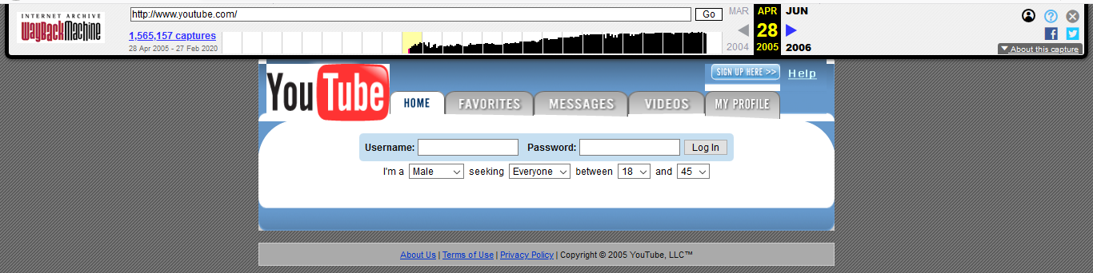

Figure 1:youtube.com on April 28,2005

* It had not scroll feature.
* It had very simply requirement to Log In because of this it seemed that it had some security issue.
* It has not more kind of web page color
* It had color change while used that page and leave that page on the page link
* It had home, favorites, messages, videos and my profile pages

### On March 03, 2006

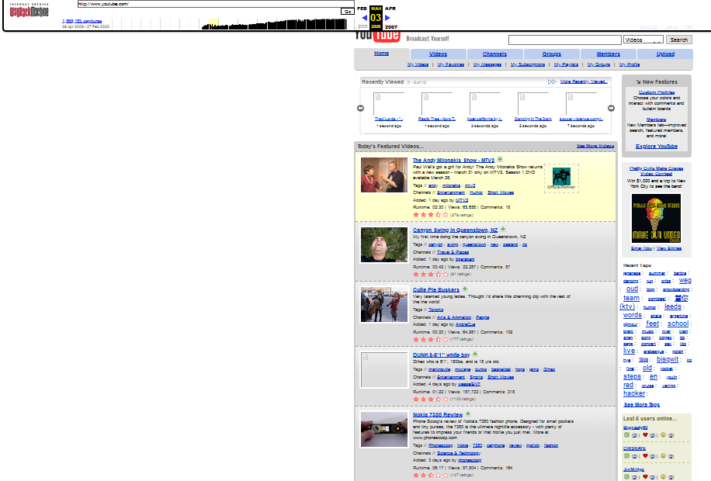

Figure 2: youtube.com on march 03, 2006

* It had not scroll feature
* It had color change while used that page and leave that page on the page link
* It had arrow to go through more recently viewed
* Videos were easily download by downloading arrow on the video
* It had showed comments, views and runtime of the video
* The page was very attractive to see
* It had an access to see last 5 users online
* It had home, videos, channel, group, member and upload pages

### On March 31 2007

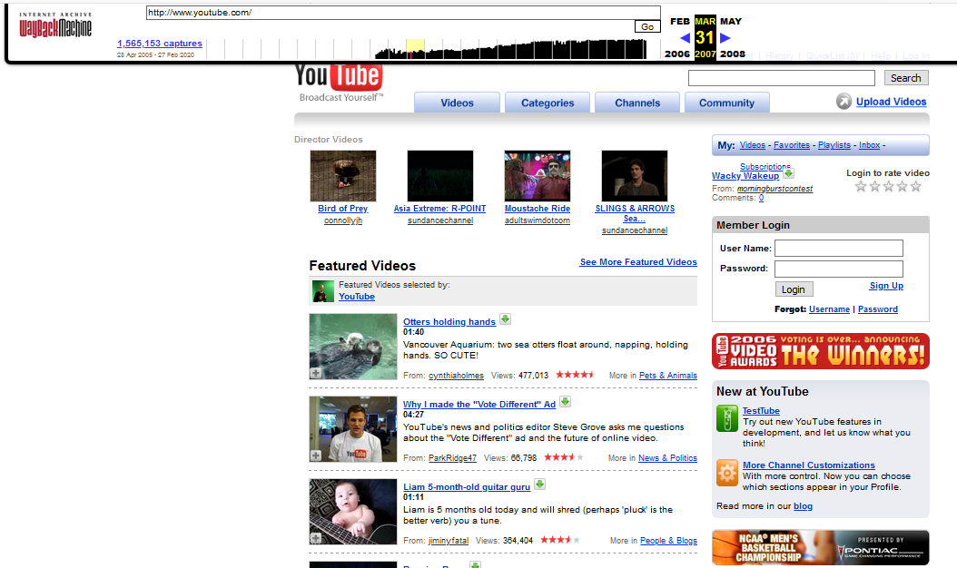

Figure 3: youtube.com on march 31, 2007

* It uses more blog
* It’s Log In form had an advantage for someone who forgot his password
* It had videos, categories, channels and community pages
* It had showed videos duration
* It had downloading pages
* It used star to show number of viewers
* It had color change while used that page and leave that page on the page link

### On April 16, 2008

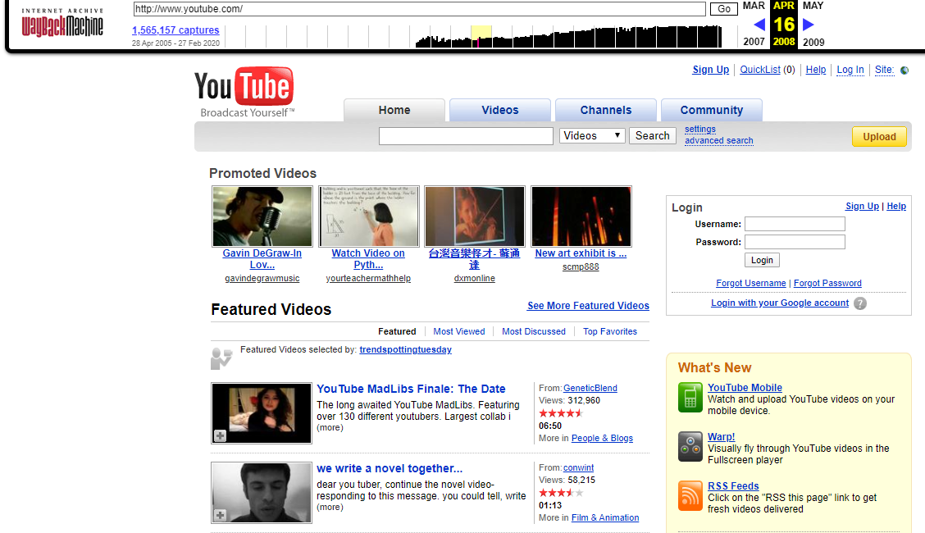

Figure 4: youtube.com on April 16, 2008

* It gave Additional Log In way which is Login with your google account
* It had home, videos, channels, community page links
* It had link to see more featured videos
* It used star to show number of viewers
* It had color change while used that page and leave that page on the page link
* It had smart structure and view when it was seen by eye rather than the previous

### On April 02 2009

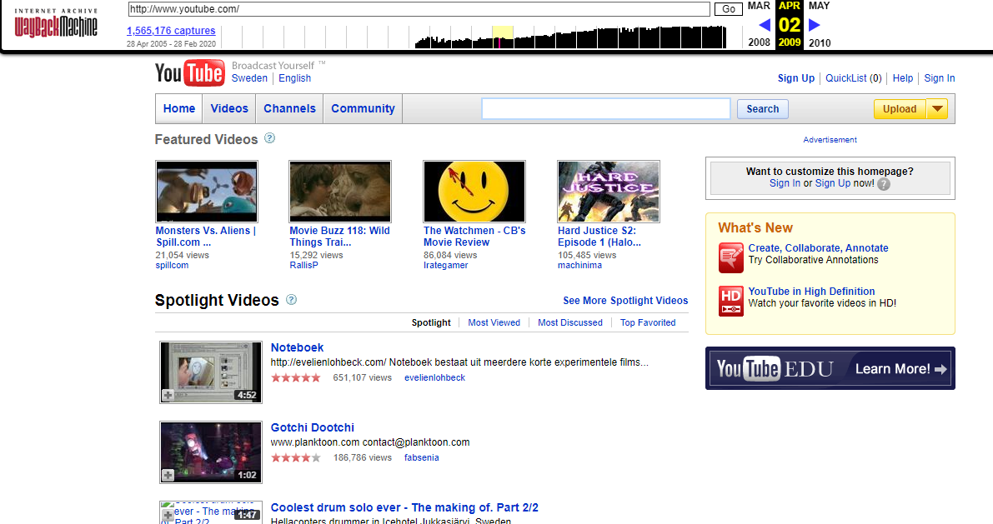

Figure 5: youtube.com on April 02, 2009

* It had home, videos, channels and community page links
* It had an advance to see more spotlight videos
* It used star to show number of viewers
* In the community page link, it had contests, events, groups, community help forums part
* It also has an advertisement part in the community page link
* It had not scroll feature
* It had a color change while someone hover around the page link

### On August 10, 2010

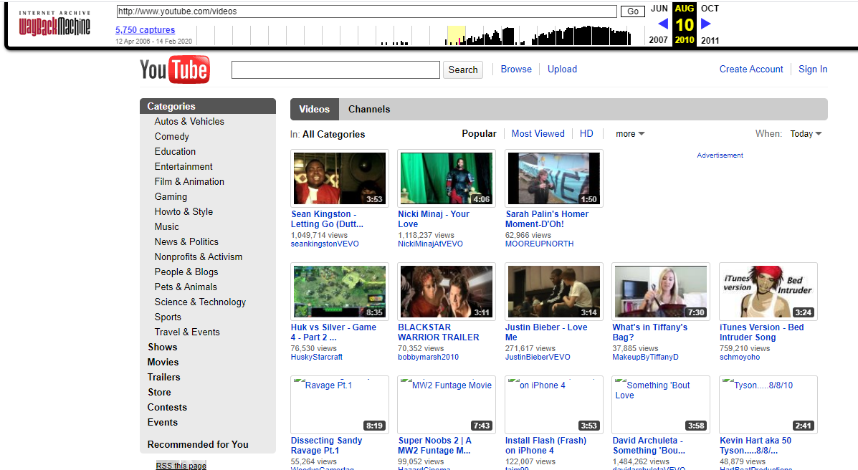

Figure 6: youtube.com On August 10, 2010

* It had not main page links like home, message, videos etc.… instead of that it had one main pages
* It had a future to find desired videos by writing the videos name in the box that is near to the search button
* It had browse and upload link
* The create account and sign in features had only seen the link but around the beginning of this feature, there also the futures that show the qualification to sign in to YouTube

### On April 12, 2012

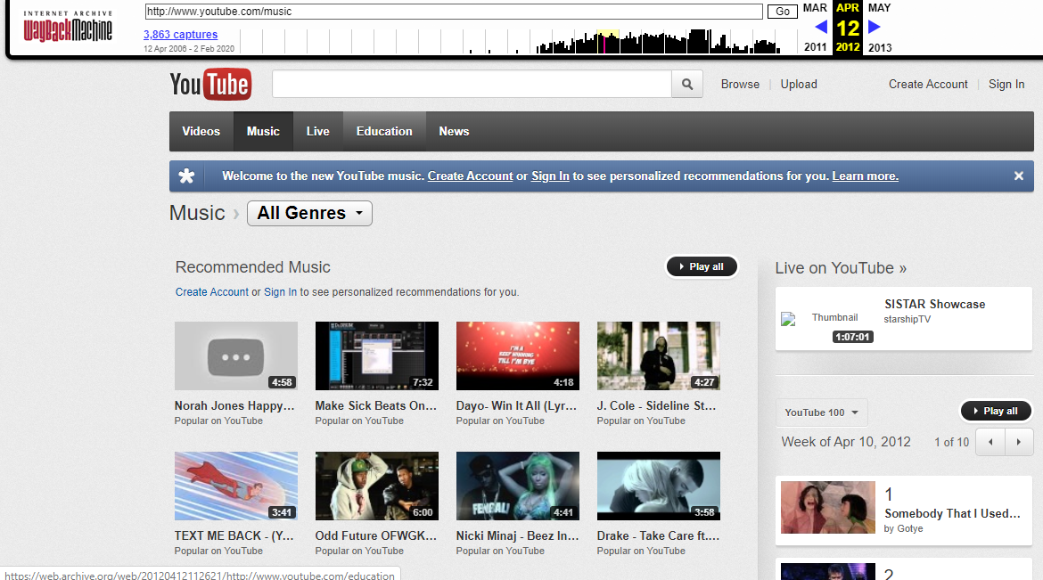

Figure 7: youtube.com on April 12 2012

* It had videos, music, live, education and news page links
* It had hover link and active link
* It had a category based on the purpose of the videos

### On June 30, 2015

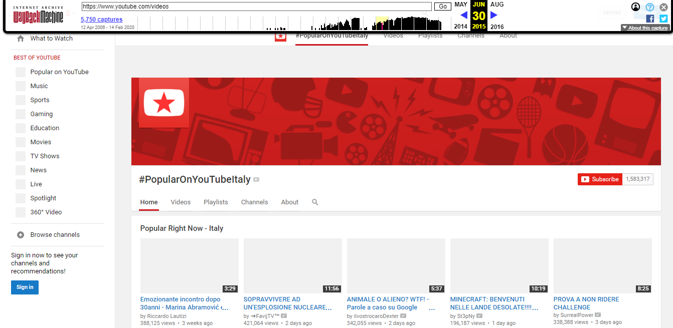

Figure 8: youtube.com on June 30, 2015

* It had showed number of subscribers
* It had home, videos, playlists, channels and about pages
* It also has an advertising page as shown below

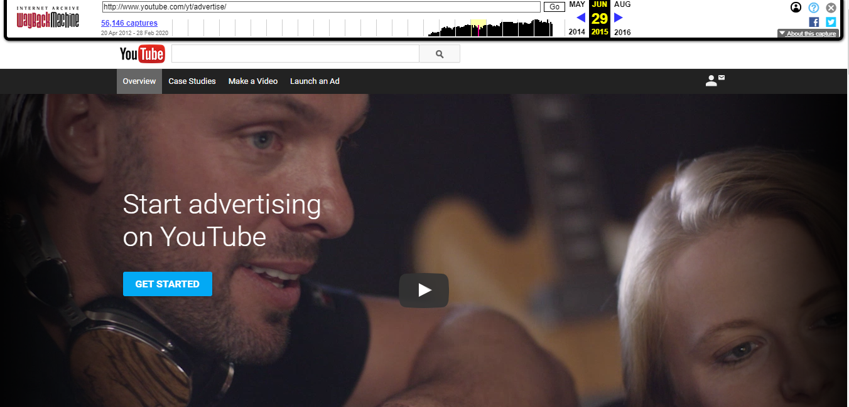

Figure 9:advertising page of youtube.com on June, 2015

### On July 14, 2017

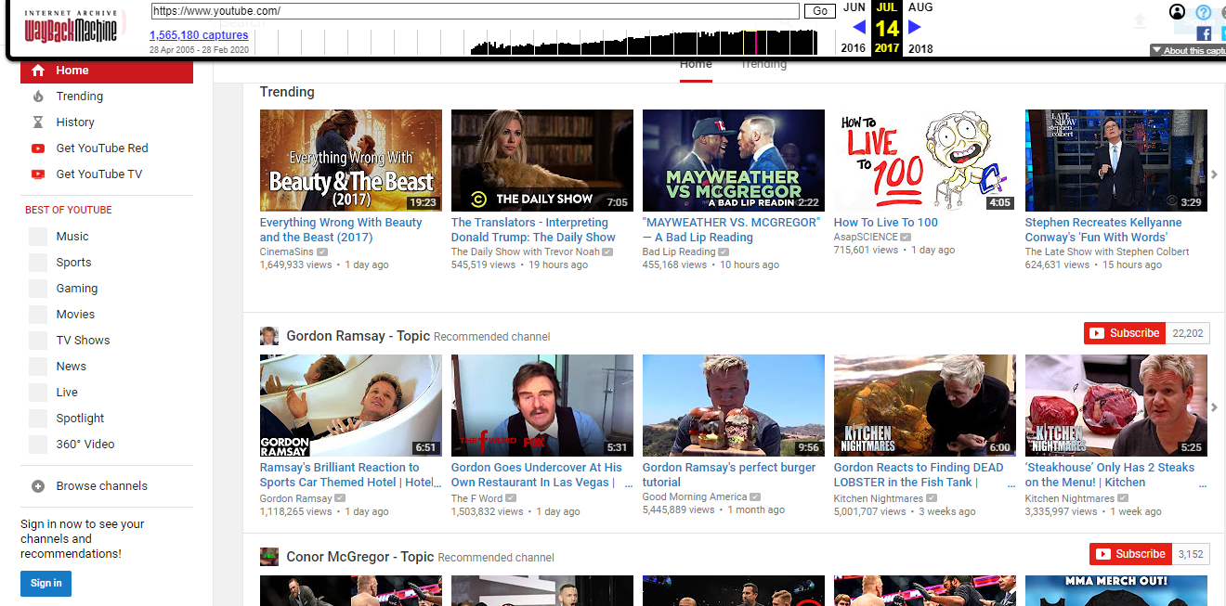

Figure 10: Youtube.com On July 14, 2017

* It had more advanced features such as trending, history, get You Tube Red and get You Tube Tv
* It has a category to choose the desired type of You Tube
* It was very attractive to seen

### On April 30, 2019

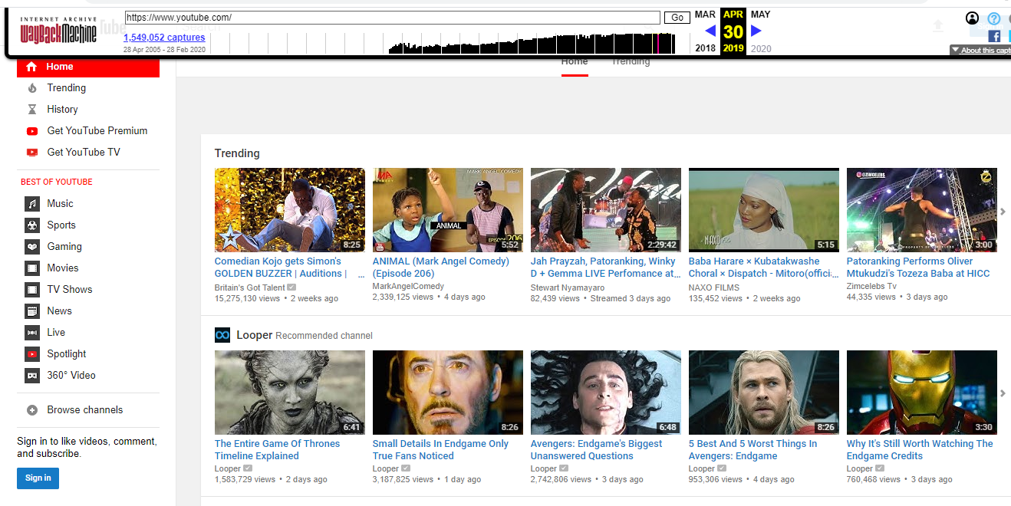

Figure 11: youtube.com on April 30, 2019

* It had the same feature as the previous I described YouTube on July 14 2017

## AAU

### On April 15, 2016

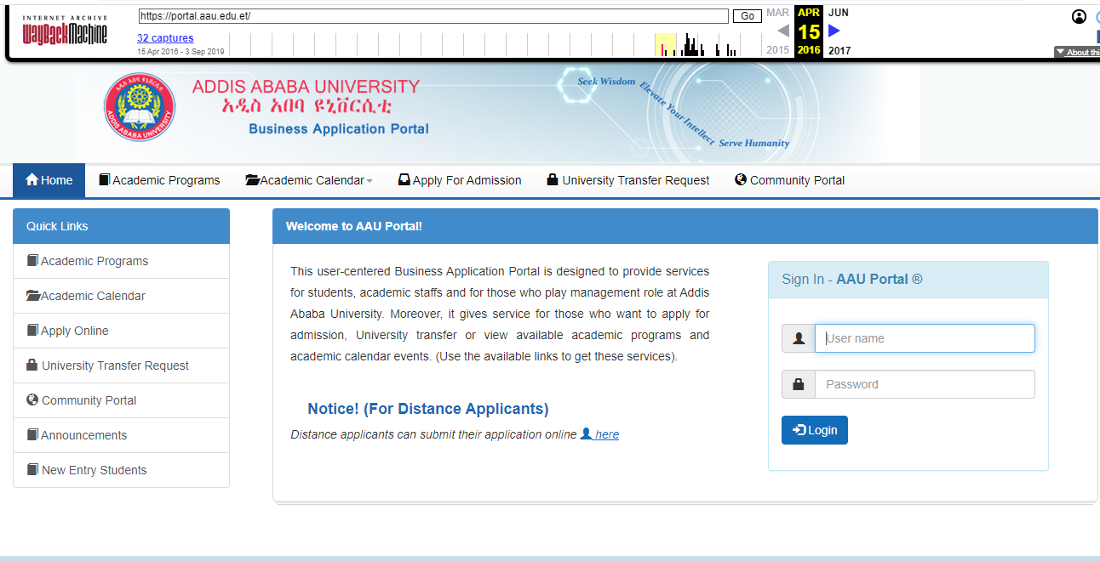

Figure 12: aau.edu.et on April 15, 2016

* It had home, Academic programs, Academic calendar, Apply for admission, University Transfer request and community portal page links.
* Basically, it had two tables in a column. The first column contains rows that were Academic Programs, Academic calendar, Apply Online, University Transfer request and community portal, Announcements and New entry students. The second column has some description and sign in table.
* Its logo is found on the top left part of the page

### On March 23, 2018

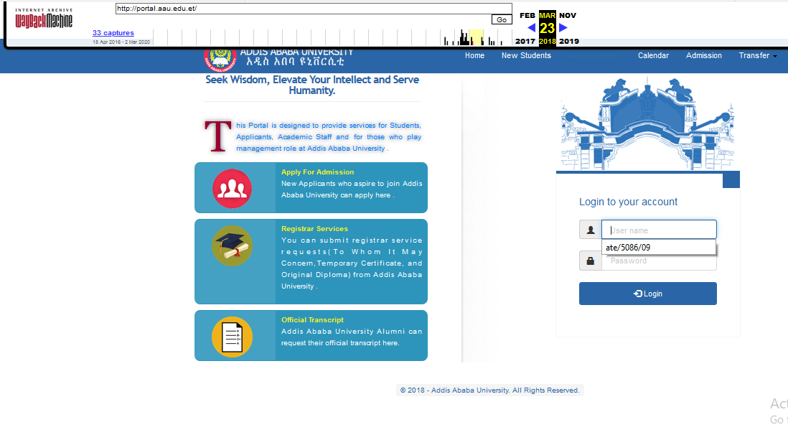

Figure 13: aau.edu.et on march 23, 2018

* It had home, new students, announcement, calendar, admission and transfer page links
* It had a logo on top left part of a page
* It had two columns. The first one contains three rows that are Apply for Admission, registrar services and official transcript links with their own logo. The second one had a logo with its entry form.

### On March 02, 2020

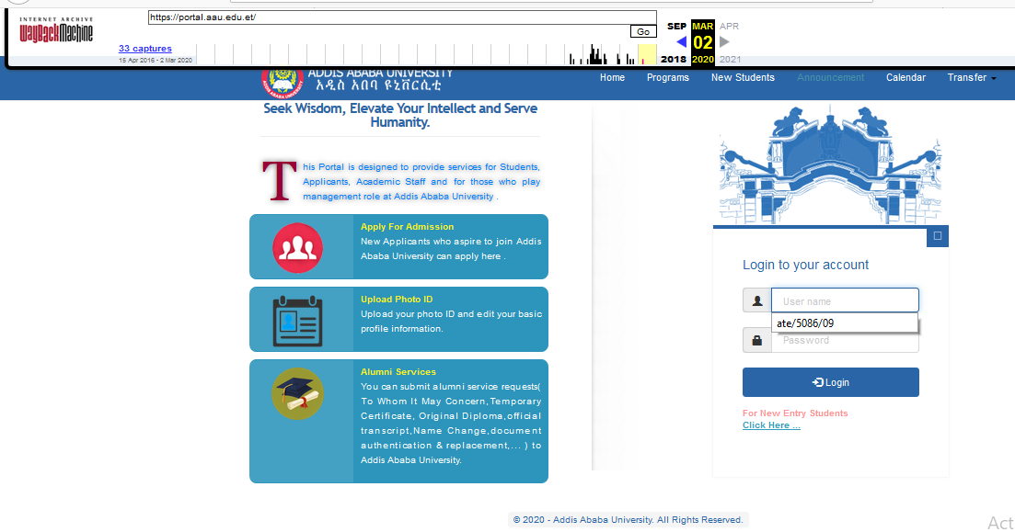

Figure 14:aau.edu.et on March 02, 2020

* The difference between this website and the previous one is: -
* For new entry student registration or entry, it put the link below the second column
* It replaces the admission page link by programs page link
* The first column second and third rows are replaced by Upload Photo ID and Alumni Services respectively

## Yahoo!

### On October 17, 1996

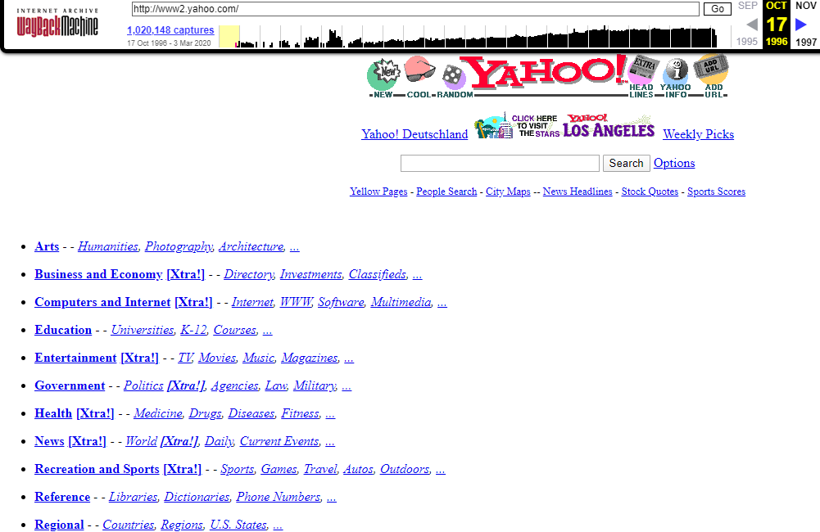

Figure 15: yahoo.com on October 17, 1996

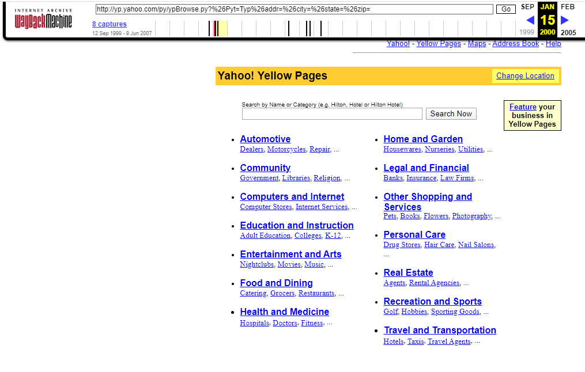

Figure 16: yahoo yellow page on October 17, 1996

* It had a future to find desired thing by writing the desired name in the box that is near to the search button
* It had yellow pages, people search, city Maps, News Headlines, Stack Quotes and Sports Scores page links
* It had not smart structure and view when it was seen by eye
* It had not scroll feature
* It had not all page links on the yellow page that are found in the main page. Because of this it looks different when I inter to the yellow pages.

### On July 06, 2000

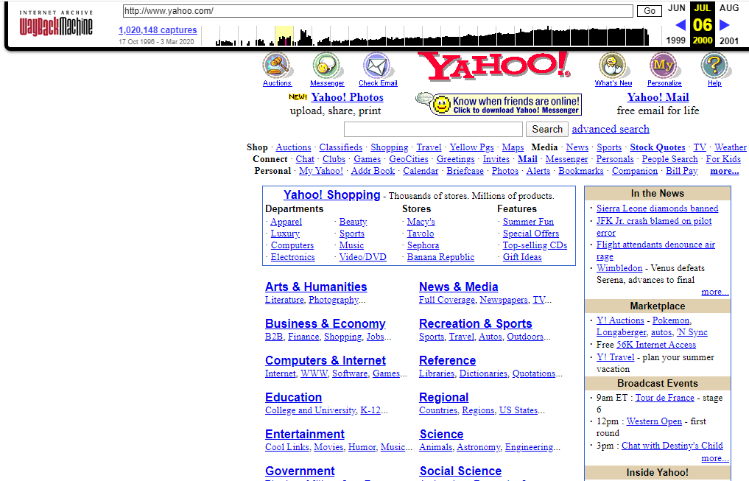

Figure 17: yahoo.com on July 06,2000

* Its page links are categorized to shop, media, connect and personal.
* It used more textual forms on the main page.
* It had an advanced search.
* On the top of the page, it had logos with the link.
* It had an access to download yahoo! messenger.

### On July 01, 2014

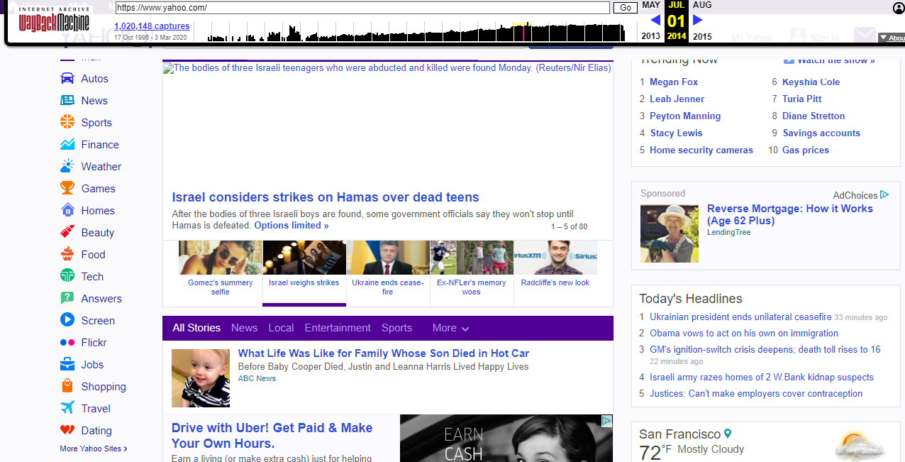

Figure 18: yahoo.com on July 01, 2014

* It had all_stories, news, local, entertainment, sports and more page links.
* It had more user need categories on the left side of it like finance, weather, games, homes, beauty, food, tech, answers, screen and so on.
* It looked attractive to see.
* It had ‘back to top’ button at the bottom of the page.

### On March 03, 2020

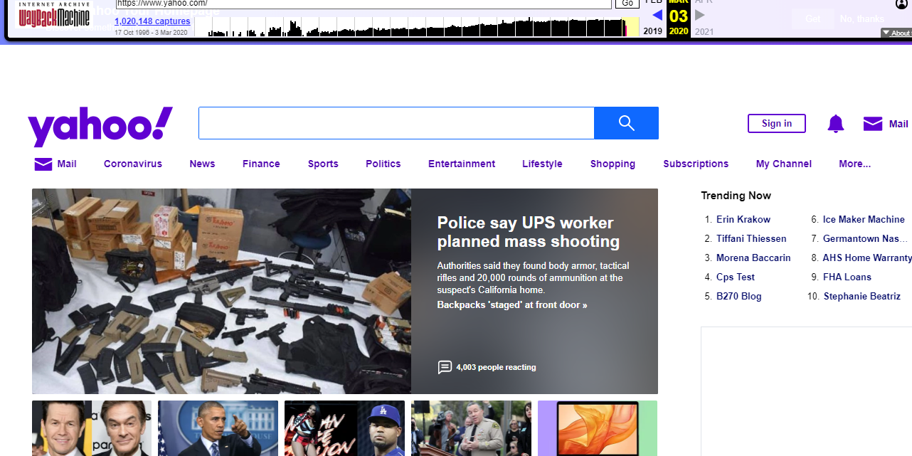

Figure 19: yaoo.com on march 03, 2020

* It has mail, coronavirus, news, finance, sports, politics, entertainment, lifestyle, shopping, subscriptions, mychannel and more page links.
* It has sign in feature to use yahoo account
* It is attractive to see

## Amazon

### On May 22, 2006

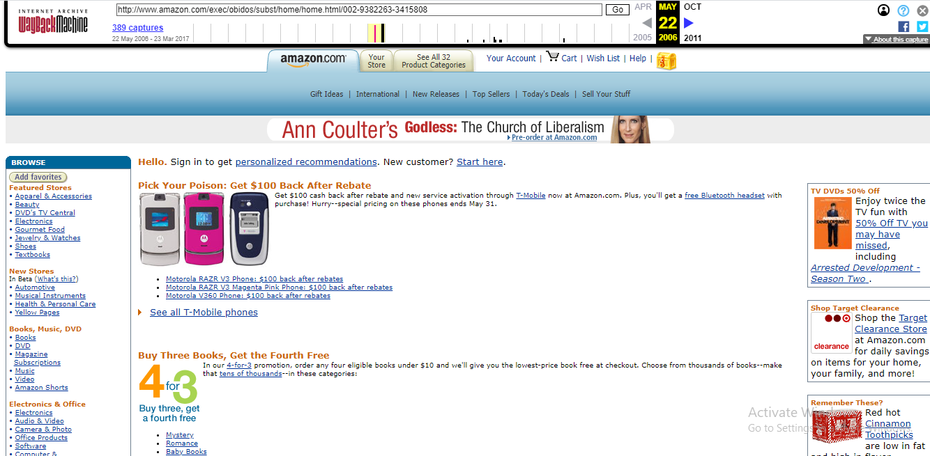

Figure 20:amazon.com on May 22,2006

* It had sign in features to get personalized recommendations. And also, for new customers it had start here link near to the sign in.
* Its amazon.com page had things with their prices
* It had a feature to browse our need on the left of the page.
* It has amazon.com, your store, see all 32 product categories page links.

### On October 18 2011

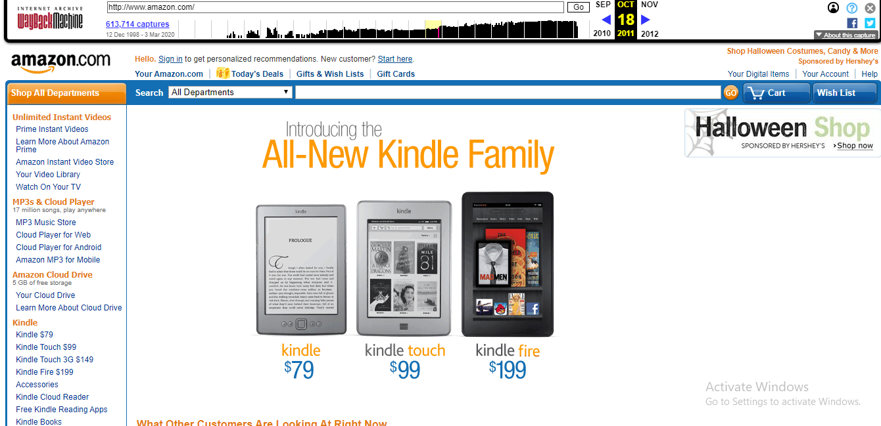

Figure 21: amazon.com on October 18,2011

* Its cart and wish list link on the previous observation were found on the top right part of page links. But in this observation, they found near to the searching box in the form of button.
* On the left of the page there are categories which show list of products.
* It had your_amazon.com, today’s deals, gifts and wish lists and gift cards page links.

### On March 23, 2017

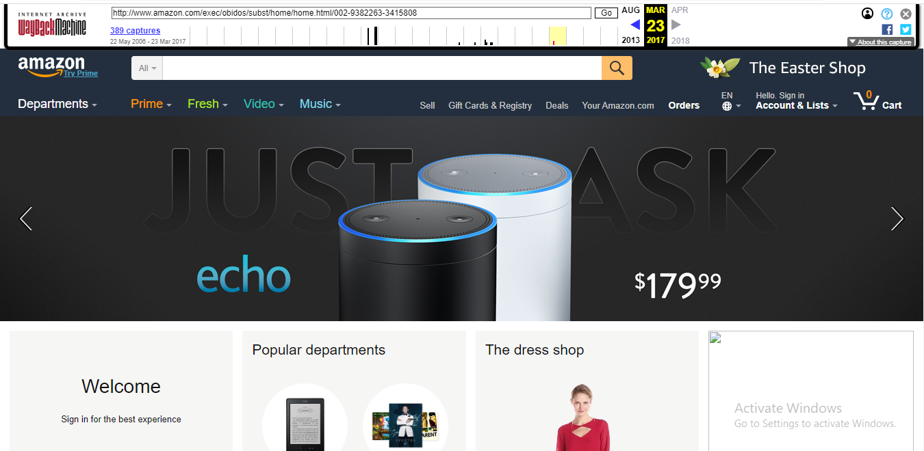

Figure 22:amazon.com on March 23,2017

* It had amazon logo
* It had a button which displays a list of departments when clicked on it
* It had prime, fresh, video and music page links
* On the previous observation international sites of amazon are listed side by side but in this year website the sites were listed by combo box means when the desired box is clicked, the sites are listed.

### On March 03, 2020

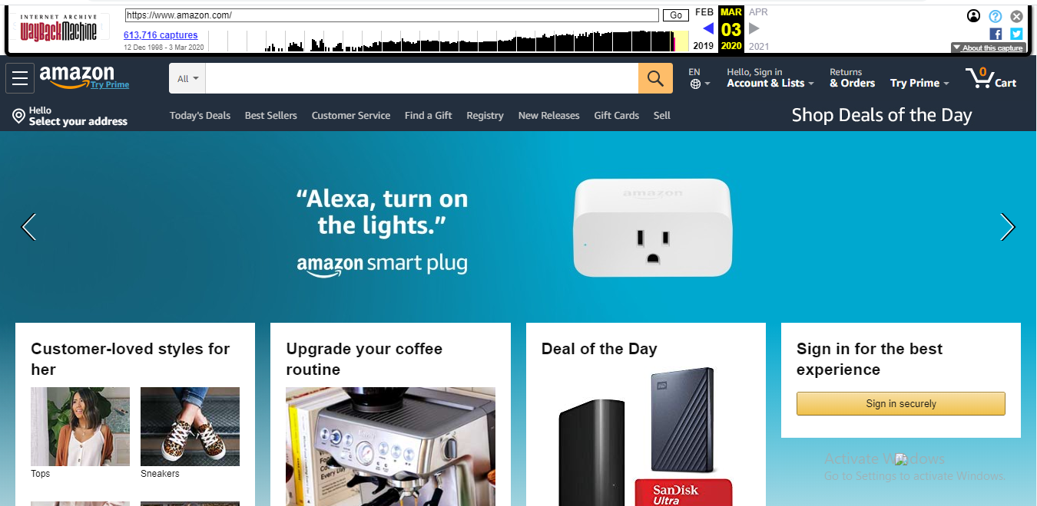

Figure 23:Amazon .com on March 03, 2020

* It has Today’s deals, best sellers, customer service, find a gift, registry, new releases, gift cards and sell page links
* It is very attractive to see compare to the previous one
* It has a component structure change at the top right of the page compare to the previous.

## Wikipedia

### On March 31, 2001

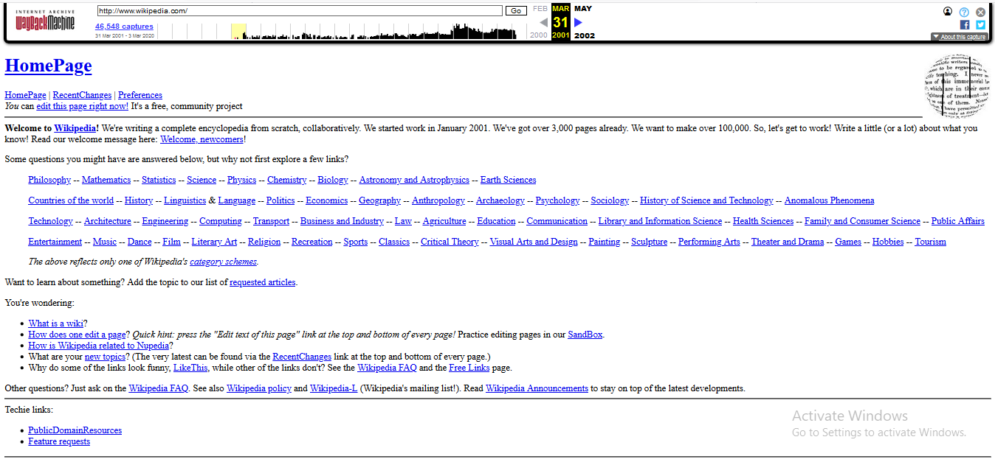

Figure 24: Wikipedia.com on March 31,2001

* It had a lot of links on the home page
* Its logo is found on the top right corner of the page
* Paragraph on this page uses full width
* The pages were covered by texts rather than images.
* It was pure HTML work

### On April 17, 2007

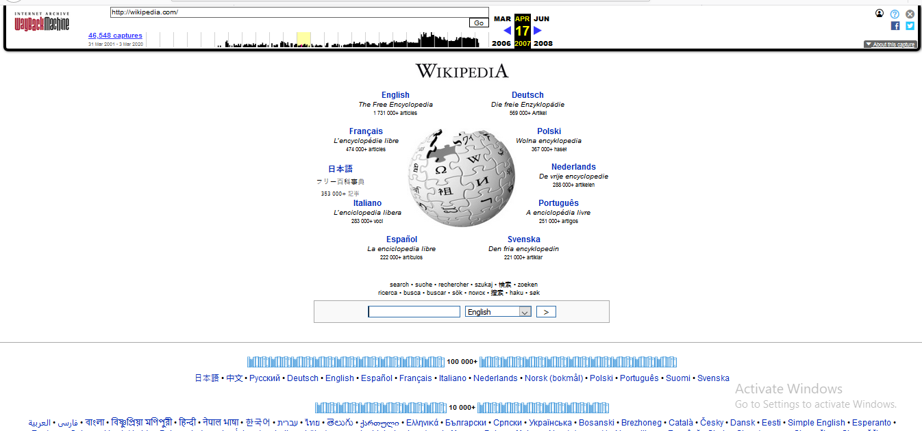

Figure 25:Wikipedia.com on April 17,2007

* It had a logo on the top center of the page
* Below its logo it has a text box which was used to search our need and near to it there was combo box to choose language
* It also pure HTML work

### On May 15, 2014

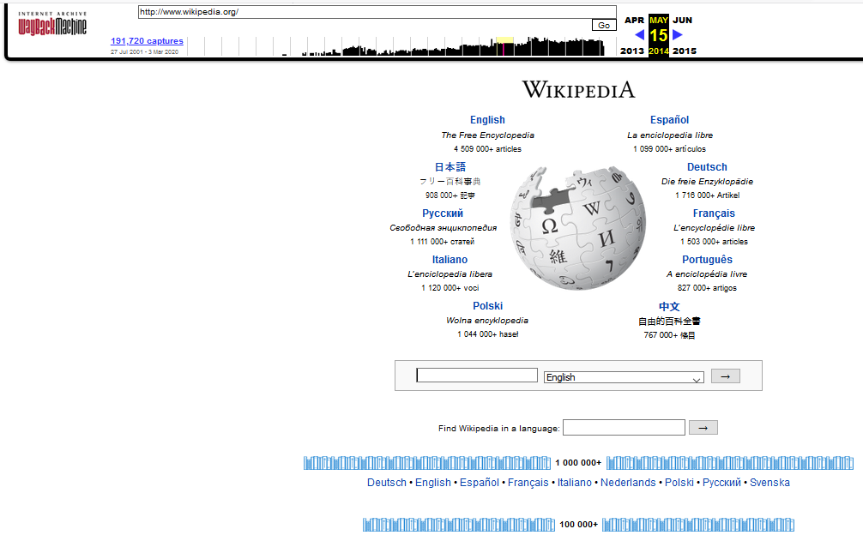

Figure 26:Wekipedia.com on May 15, 2014

* It had a logo on the top center of the page
* It also pure HTML work
* The main difference b/n the previous website and this was, the links above the searching box is not found in this website

### On March 03 2020

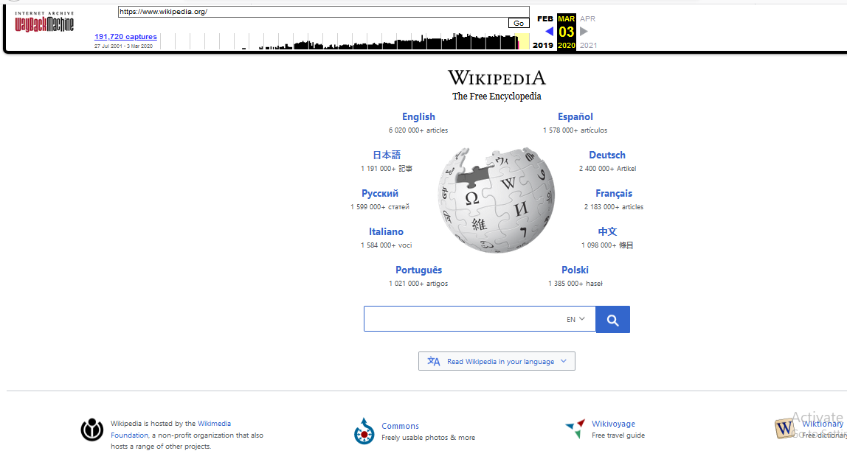

Figure 27:Wikipedia.com on March 03, 2020

* The combo box which was used to choose the language and the searching text box is joined and it looks one box
* It had a logo on the top center of the page
* It is attractive to see than the previous

# 5 website each on the 12 categories we learned

## Portal Websites

A web portal is a specially designed website that brings information from diverse sources, like emails, online forums and search engines, together in a uniform way. Usually, each information source gets its dedicated area on the page for displaying information; often, the user can configure which ones to display.

* Australian Government

<https://www.australia.gov.au/> -for Australia.

* U.S. Department of Labor

<https://www.dol.gov/odep/topics/disability.htm> -for citizens with disabilities in the United States.

* European Union

<https://europa.eu/> -links to all EU agencies and institutions in addition to press releases and audiovisual content from press conferences.

* USA Gov en Español

<https://www.usa.gov/espanol/> for the United States (in Spanish).

* GOV.UK

<https://www.gov.uk/> for citizens

* EU Portal Public Health

<https://www.eea.europa.eu/themes/human/links/health-eu-portal> -gathers all relevant health topics from across Europe.

* National Portal of India

<https://www.india.gov.in/> -for India.

* National Resource Directory

<https://nrd.gov/> links to resources for United States Service Members, Veterans and their families.

* USA.GOV

<https://www.usa.gov/> for the United States (in English).

* Digital Public Library of America

<https://dp.la/> (in development) digital public library of America

* DIGITALNZ: - <https://digitalnz.org/> – A cultural portal led by the National Library of New Zealand focused on New Zealand digital content.
* EUROPEANA: - <https://www.europeana.eu/portal/en> – A cultural portal for the European Union based in the National Library of the Netherlands and overseen by the Europeana Foundation.
* TUT: - <https://www.tut.by/> - A commercial cultural portal focused on Belarusian digital content.

## News Websites

* Yahoo News

<https://news.yahoo.com/> -Yahoo! News is a news website that originated as an internet-based news aggregator by Yahoo!.

* Sports Illustrated

<https://www.si.com/> -It is the online platform of Sports Illustrated. It is a North American sports news magazine.

* Forbes

[https://www.forbes.com](https://www.forbes.com/#b19099f2254c) -Forbes is a business magazine covering finance, industry, investing, and marketing and its online platform. It handles large volumes of content and traffic. Its minimalist design and simple navigation perfectly parallel the publication's austere and straightforward tone, resulting in a nicely balanced online news portal that performs exactly as it should.

* Hollywood Reporter

<https://www.hollywoodreporter.com/> -The Hollywood Reporter is a heavyweight in the entertainment news industry. While perhaps entertainment news isn't regarded with the same respect as other forms of journalism, it does cover a constantly-changing, billion-dollar industry that influences large swaths of the populace, and the Hollywood Reporter's website is a go-to destination for many people. The fact that the publication chose an open source CMS to handle its content and traffic demands speaks volumes.

* Mother Jones

<https://www.motherjones.com/> -Mother Jones is an American magazine featuring investigative and breaking news reporting on politics, the environment, human rights, and culture

* Patch Media

<https://patch.com/> -Patch Media is an innovative online local news and information platform

## Informational Websites

Informational websites are those sites that are created in order to provide a customized and branded resource for potential and active customers, members, investors and so forth.

* Wikipedia

<http://www.wikipedia.org/> - Wikipedia.org is a well-known free internet encyclopedia. It has been a trusted source of information on various subjects.

* CNET

<http://www.cnet.com/> - CNET.com provides tech news; product review, and prices, offer software downloads. This is listed as one of the most informative websites categorized in technology news and information.

* AOL

<http://aol.com/> - AOL Inc. is a New York City based multinational mass media corporation. And website of AOL Inc. has ranked one of the informative websites.

* WHO

<http://who.int/> - Website of WHO (World Health Organization) provides disease outbreak news, information about emergencies and disasters, factsheets and related information.

* Nobel Prize

<http://www.nobelprize.org/> - Nobelprize.org one of the informative websites, specially it gives scholarship information

* Guinness World Records

<http://www.guinnessworldrecords.com/> - This is the official website of Guinness World Records

* Stack overflow

<http://stackoverflow.com/> - Stack overflow is a question and answer site for professional and enthusiast programmers.

* W3

<http://www.w3.org/> - W3.org has mission to lead the WWW (World Wide Web) to its full potential by developing protocols and guidelines that ensure the long-term growth of the web

* Facebook

<http://www.facebook.com/> - Now Facebook has become first source of different information like, local news, and local debates.

* You Tube

<http://www.youtube.com/> - YouTube is also a most informative websites.it gives more information by the means of videos.

## Business/ Marketing Websites

* yelp

<https://biz.yelp.com/> - The mere mention of popular social review site Yelp tends to strike fear in business owners everywhere.

* Twitter

<https://business.twitter.com/?lang=en&location=na> - Twitter has become an important way to network with other business owners, but it can also be used for promotion.

* LinkedIn

<https://www.linkedin.com/> - LinkedIn is a great way to network with other business owners and find great workers.

* Foursquare

<https://support.foursquare.com/hc/en-us/articles/201063930-How-to-claim-your-listing-s-> -This website can help customers to find you, in addition to your own website and social media sites by listing on FourSquare.

* Facebook

<http://www.facebook.com/> -As the reigning king of social media, Facebook is still an essential social media marketing tool for businesses.

* LinkedIn (businesseslink.gov.uk)

[https://www.linkedin.com/company/businesslink.gov.uk](https://www.linkedin.com/company/businesslink.gov.uk ) for businesses in the United Kingdom.

## Educational Websites

* Edx

<https://www.edx.org/> - EdX is an online learning destination and MOOC provider, offering high-quality courses from the world's best universities and institutions to learners everywhere.

* Academic Earth

<https://academicearth.org/> - The website gives huge array of academic options to student from traditional to contemporary studies. They provide online degree courses from accounting and economics to engineering and also carries material on niche subjects like behavioral psychology. Moreover, it has a collaboration with a bunch of reputed colleges such as University of Oxford, Massachusetts Institute of Technology, Stanford University and many other.

* Internet Archive

<https://archive.org/> - From anything to everything, internet archive is an authentic website storing the originals from various big websites.

* Big Think

<https://bigthink.com/> - Students can make great use of this website by creating their own distinct ideology, as it provides various opinions on one subject.

* Coursera

<https://www.coursera.org/> - It is a user-friendly website. Students can find big universities and a sharable electronic Course Certificate.

* Brightstorm

<https://www.brightstorm.com/> -It provide help in all subjects from mathematics to science, history and other subjects.

* CosmoLearning

<https://cosmolearning.org/> -The website is synthesized with three main options, including educational material, courses and documentaries. The subjects have been divided into two sections, namely extra-curricular and academic subjects.

* Futures Channel

<https://thefutureschannel.com/#loaded> -Unlike other websites, it only represents the significant data catering the problems faced by students. For example, students generally face problem in algebra, so they have created special section for the same.

* Howcast

<https://www.howcast.com/> -It's a one-stop website for all the subjects.

* Khan Academy

<https://www.khanacademy.org/> -Khan Academy is an online coaching website. It gives a win-win situation to the students by giving them the liberty to learn on their pace, as it has a personalized dashboard to gauge the progress report. It has all the traditional school subjects including math, science, computer programming, history, art history, economics, and more. Moreover, it has lessons from kindergarten to calculus, all at one stop. To enhance the content for the students, it has partnered with NASA, the Museum of Modern Art, the California Academy of Sciences, and MIT.

## Entertainment Websites

* ESPN

<https://africa.espn.com/> -**It provides complete sports information** including NFL, MLB, NBA, College Football, College Basketball scores and news. ESPN, Inc., The Worldwide Leader in Sports, is **the leading multinational, multimedia sports entertainment company** featuring the broadest portfolio of multimedia sports assets with over 50 business entities.

* TMZ

<https://www.tmz.com/> -The term “Thirty Mile Zone” originated in the 1960s, when due to the growth of location shoots, studios established a “thirty-mile zone” to monitor rules for filming in Hollywood.  Launched in 2005, TMZ’s meteoric rise followed its exclusive on two of the biggest stories in **entertainment**: Mel Gibson’s DUI arrest and subsequent encounter with law enforcement, and Michael Richards’ ill-fated trip to the Laugh Factory. TMZ altered the entertainment news landscape by changing the way the public gets its news instant, with lots of juicy headlines, and full of gossip.

* IMDb

<https://www.imdb.com/> - IMDb (Internet Movie Database) is the **world’s most popular and authoritative source for movie, TV and celebrity content.** IMDb is the first movie website in the world with a combined web and mobile audience of more than 160 million unique monthly visitors. It offers a searchable database of more than 130 million data items including more than 2 million movies, TV and entertainment programs and more than 4 million cast and crew members.

* You Tube

<https://www.youtube.com/> -It provides a forum for people to connect, inform, and inspire others across the globe and acts as a distribution platform for original content creators and advertisers large and small. Since it took over the web by storm, **it is undoubtedly the most immediate, vast and popular source for video entertainment online.**

* Fandango

<https://www.fandango.com/?cjid=cj_10485556_2477067_&cjevent=b22deb955b4511ea830501e30a18050e> -Fandango is the nation’s leading moviegoer destination. It **sells tickets to more than 20,000 screens nationwide.** Fandango entertains and informs consumers with reviews, commentary, celebrity interviews and trailers, and offers the ability to quickly select a film, plan where and when to see it, and **conveniently buy tickets in advance.**

## Advocacy websites

* Advocates for Children in Therapy (ACT)

<http://www.childrenintherapy.org/> -**Advocates for Children in Therapy is an educational and public advocacy organization dedicated to halting the dangerous cruelty done to children by Attachment Therapy, its associated “therapeutic parenting” practices, and other unvalidated, pseudoscientific interventions for the unrecognized diagnosis called “Attachment Disorder.”**

* Alliance for Human Research Protection (AHRP)

<https://ahrp.org/about/> **-The Alliance for Human Research Protection (AHRP)** is a national network of lay people and professionals who are committed to upholding the humanitarian values and ethical standards of medicine enshrined in the Hippocratic Oath.

* Alliance for Justice

<https://www.afj.org/> -AFJ has been a leader in galvanizing the largest and most diverse coalition of progressive advocates in our nation’s history and energizing millions of people from all walks of life to prioritize the courts. Its Bolder Advocacy program has trained thousands of nonprofits and foundations on how to advocate for their missions. Alliance for Justice is working toward a brighter and more just future.

* American Bar Association

<https://www.americanbar.org/groups/public_interest/child_law/> -Center on Children and the Law. The Center promotes access to justice for children and families. Their team of attorneys and core staff work on a diverse portfolio of national, regional and local projects in the children’s law field throughout the country. Center projects are unified by two complementary goals: improving legal representation and improving the legal systems that impact children and families.

* ASISTA

<https://asistahelp.org/about/vision-mission/> -Its vision is immigrants live in a just world free from violence. It Provide comprehensive, cutting-edge technical assistance and resources to those assisting noncitizen survivors of violence in the immigration law arena.

* Bazelon Center for Mental Health Law

<http://www.bazelon.org/> -The mission of the Bazelon Center for Mental Health Law is to protect and advance the civil rights of adults and children with mental illness or developmental disabilities.  It envisions a society where Americans with mental disabilities live with autonomy, dignity, and opportunity in welcoming communities, supported by law, policy, and practices that help them reach their full potential.

* Boston Women’s Fund

<https://www.bostonwomensfund.org/> -The Boston Women’s Fund (BWF) is a progressive foundation that supports community-based organizations and grassroots initiatives run by women and girls in order to create a society based on racial, economic and social justice.

## Blog Websites

**Blogs** are a type **of website**. The only **difference** is that **blogs** have frequently updated content and **websites** tend to be much more static and is organized into pages. A **blog** can be a **website** on its own or a part **of** a bigger **site**. Early iteration **of blogs** was once used mostly **for** online personal journals.

* Avocadu

<https://avocadu.com/> -her name is Lauren and herhealth journey really began when she was in college.

* Pinch of Yum

<https://pinchofyum.com/> -Pinch of Yum is one of the most popular [food and recipe blogs](https://www.wpbeginner.com/start-a-wordpress-blog/food-blog-recipes/) online. Started by Lindsay, a high school teacher, the blog allowed her to quit her day job and become a full-time blogger.

* WeTheParents

<https://wetheparents.org/> -WeTheParents is a popular parenting blog run by Neve and Keane (the parents). They share parenting tips for moms and dads and while doing so they make money by earning commission on products they recommend.

* We Wore what

<https://weworewhat.com/> -Started by Danielle Bernstein, We Wore What is a popular fashion blog. It covers everything from fashion to interior design to menswear.

* Nerd Fitness

<https://www.nerdfitness.com/> - A fitness blog started by Steve Kamb, Nerd Fitness is dedicated to helping people stay fit. It provides fitness advice, motivation, support, diet and exercise tips.

* Lost With Purpose

<https://www.lostwithpurpose.com/> -A popular travel blog run by Alex, who shares her journeys while offering travel tips, advice, and guides for other backpackers.

* Tiny buddha

<https://tinybuddha.com/> -Tiny Buddha is a personal development blog created by Lori Deschene. The blog publishes content on happiness, love, relationships, mindfulness, spirituality, simplicity, minimalism, letting go, and more.

## Wiki Websites

A wiki is a server program that allows users to collaborate in forming the content of a Web site. More advanced wikis have a management component that allow a designated person to accept or reject changes.

* Wikitravel

<https://wikitravel.org/en/Main_Page> -Wikitravel is a much better source of information. It’s been online since 2003 and is overseen by a team of administrators. They can roll back unwanted edits, delete pages, lock pages, and generally keep the information on the site accurate and free of spam.

* WikiHow

<https://www.wikihow.com/Main-Page> -WikiHow is a popular wiki for anyone who wants to learn how to do something. The content on offer is extremely varied. The site’s categories include topics such as **Sports and Fitness, Pets and Animals, Relationships**, and **Philosophy and Religion**.

* WikiBooks

<https://en.wikibooks.org/wiki/Main_Page> -WikiBooks makes our list of wiki sites thanks to its incredible repository of open-content textbooks, annotated texts, instructional guides, and manuals. It does not include fiction, primary research, or published texts.

* Wiktionary

<https://en.wiktionary.org/wiki/Wiktionary:Main_Page> -It is a multilingual dictionary of languages, but has a definition for every word supplied in English, regardless of the source language.

* Stranger things Wiki

<https://strangerthings.fandom.com/wiki/Stranger_Things_Wiki> -The Stranger Things wiki which is part of the Fandom network of sites is one of the best examples of a wiki about a TV series. It includes detailed information about the cast, characters, filming locations, soundtrack, and lots more.

* Wikispecies

<https://species.wikimedia.org/wiki/Main_Page> -Wikispecies is to the 21st century what “On the Origin of Species” was to the 19th century. It aims to be a complete catalog of all **Animalia, Plantae, fungi, bacteria, archaea,** and **Protista** in the world.

## Social Websites

* Facebook

<http://www.facebook.com/> - This is easily the largest social networking site in the world and one of the most widely used. And, Facebook was perhaps the first that surpassed the landmark of 1 billion user accounts.

* WhatsApp

<https://www.whatsapp.com/> -has been able to capture the imagination of millions of people across the world by giving them the ability to communicate and share instantly with individuals and groups.

* QQ

<https://www.qq.com/> -Tencent QQ (more popularly known as QQ) is an instant messaging social media platform. It became international, after it was launched in China.

* WeChat

<https://www.wechat.com/en> -This is an all-in-one communications app for messaging and calling (similar to WhatsApp) that enables you to connect with the people of your choice.

* QZone

<https://qzone.qq.com/> -QZone social networking service developed by Tencent. It enables you to share photos, watch videos, listen to songs, write blogs, maintain diaries and so on. It also empowers you to choose the accessories and customize the look and feel of your QZone webpages.

* Tumblr

<https://www.tumblr.com/> -Tumblr serves as a social media cum micro blogging platform that can be used to find and follow things that you like. You can also use it to post anything, including multimedia, to a short-form blog. Moreover, it gives you the flexibility to customize almost everything.

* Instagram

<https://www.instagram.com/> -Instagram was launched as a unique social networking platform that was completely based on sharing photos and videos. This photo sharing social networking app thus enables you to capture the best moments of your life, with your phone’s camera or any other camera, and convert them into works of art.

## Content Aggregator Websites

* Alltop

<https://alltop.com/> -Founded by startup legend Guy Kawasaki, Alltop is one of the biggest names in content aggregation and deservedly sits in first place on this list. Alltop pulls in the latest posts from websites on a variety of topics. What’s neat about Alltop is that you can search for specific topics and then view aggregated content from some of the top blogs for that specific topic.

* Popurls

<http://popurls.com/> -Popurls pulls in content from a variety of social networks, blogs, and news organizations. It’s quite eclectic in its content.

* The Web List

<https://theweblist.net/> -it’s a one-page content aggregator website that collects content from a huge variety of sources. It is customizable and uses some cool technology.

* WP News Desk

<http://wpnewsdesk.com/> -WP News Desk is a content aggregator website that focuses specifically on WordPress. It automatically pulls in content from a variety of WordPress blogs and companies and displays posts on the front page.

* Blog Engage

<http://www.blogengage.com/> -Though Blog Engage is starting to fall victim to spammy content, it’s still one of the most popular blog content aggregators out there.

* Travel Blogger Community

<http://travelbloggercommunity.com/> -Travel Blogger Community is for travel bloggers what WP News Desk is for WordPress. That is, Travel Blogger Community aggregates content from travel bloggers all around the world in one accessible place.

## Personal Websites

* Gary Sheng

<http://www.garysheng.com/> -Sheng’s website makes it easy for him to include logos and clickable links that allow his software engineering and web development skills to shine.

* Pascal Van Gemert

[http://www.pascalvangemert.nl](http://www.pascalvangemert.nl/#/experiences) -Pascal van Gemert is a web developer from the Netherlands, and his personal website proves you can include a lot of information on a single webpage if it's organized properly.

* Sean Halpin

<http://seanhalpin.io/> - Halpin's website is short, sweet, and to the point, which is authentic to his voice and personal branding outlined on the site.

* Quinton Harris

<http://quinntonharris.mystrikingly.com/> - Harris's website uses photos to tell his personal story and it reads kind of like a cool, digital scrapbook. It covers all the bases of a resume by discussing his educational background, work experience, and skills in a highly visual way.

* Brandon Johnson

<http://brandoncjohnson.com/> -Johnson's incredible website must be seen to be believed. Beautiful images of planets help to complement his planetary science background, and animations make his resume more of an experience than a document.

# Evaluation of Websites

## Guidelines for Evaluating Websites

The following checklist are combined from several sources. They are a summary of criteria for evaluating Web sites. The more criteria a site meets, the more likely it is to be a valuable resource.

### Accuracy

Accuracy is the reliability, truthfulness, and correctness of the content. When evaluating based on accuracy, questions that are asked are:

* Reliability: Is the author affiliated with a known, respectable institution?
* References: do statistics and other factual information receive proper references as to their origin?
* Does the reading you have already done on the subject make the information seem accurate?
* Is the information comparable to other sites on the same topic?
* Does the text follow basic rules of grammar, spelling and composition?
* Is a bibliography or reference list included?

### Authority

Authority reveals that the person, institution or agency responsible for a site has the qualifications and knowledge to do so. Evaluating a web site for authority:

* Authorship: It should be clear who developed the site.
* Contact information should be clearly provided: e-mail address, snail mail address, phone number, and fax number.
* Credentials: the author should state qualifications, credentials, or personal background that gives them authority to present information.
* Check to see if the site supported by an organization or a commercial body
* Does the information relate to the individual’s topic or answer his/her question?

### Purpose

The purpose of the information presented in the site should be clear. Some sites are meant to inform, persuade, state an opinion, entertain, or parody something or someone. When evaluating based on purpose, questions that are asked are:

* Does the content support the purpose of the site?
* Is the information geared to a specific audience (students, scholars, general reader)?
* Is the site organized and focused?
* Are the outside links appropriate for the site?
* Does the site evaluate the links?
* Check the domain of the site. The URL may indicate its purpose.

### Currency

Currency of the site refers to:

* how current the information presented is? and
* how often the site is updated or maintained?

It is important to know when a site was created, when it was last updated, and if all of the links are current. Evaluating a web site for currency involves finding the date information was:

* first written
* placed on the web
* last revised

Then ask if:

* Links are up-to-date
* Links provided should be reliable. Dead links or references to sites that have moved are not useful.
* Information provided so trend related that its usefulness is limited to a certain time period?
* the site been under construction for some time?

### Relevance

Relevance is the importance of the information for an individual’s needs. When evaluating based on relevance, questions asked are:

* Does the information relate to the individual’s topic or answer his/her question?
* Who is the intended audience?
* Is the information at an appropriate level (not too basic or advanced for your needs)?
* Has the individual looked at a variety of sources before determining this is the best one to use?
* Would the individual be comfortable using this source for a research paper?

### Coverage

It is difficult to assess the extent of coverage since depth in a site, through the use of links, can be infinite. One author may claim comprehensive coverage of a topic while another may cover just one aspect of a topic. Evaluating a web site for coverage:

* Does the site claim to be selective or comprehensive?
* Are the topics explored in depth?
* Compare the value of the site’s information compared to other similar sites.
* Do the links go to outside sites rather than its own?
* Does the site provide information with no relevant outside links?

## Evaluating Websites based on the Guidelines

The following websites are evaluated based on the guidelines stated above.

### GREENPEACE

URL: -<http://www.greenpeace.org/international/en/>

**Accuracy**

* **Kind of information -** a thorough web site with ample links and further information, more opinion based but does provide some evidence for statements made
* **Objectivity** - Does take a certain political view point and only provides evidence to support its viewpoint.  Would need to look at other sources of information for a more subjective overview of conservation and the environment
* **Primary / Secondary source** - generally, provides primary source information (about their actives)

**Authority**

* **Author -** Most of the articles are written by "Greenpeace" rather than any individual. Greenpeace is an organization with a high public profile and the authority of material here is therefore dependent on how you view the credibility of the organization generally. About us section provides Governance and financial reports
* **References** - Articles often have statistics and other information to back up its arguments
* **Information provided** - Articles are politically charged but would agree with the environmental movement in general
* **Organization** - .org not for profit but do rely heavily on fundraising

**Purpose**

* Greenpeace want to convince you that its stance on conservation and the environment is true and justified.  It wants you to donate money or take part in the organization.
* The content supports the purpose of the site.
* The information is geared to a specific audience.
* The site organized and focused to its purpose.
* The outside links are appropriate for the site.
* The URL indicate its purpose.

**Currency**

* copyright date of 2013 with many up to date news bulletins and clips

**Relevance**

* **Audience** - General public, especially with an interest in conservation and the environment
* **Language** - well written but with some emotive language and imagery e.g. Disaster and the Skull image on front page
* **Connection (relevance) to task** - If your question was about conservation, endangered animals etc., a good place to look for background and current information
* **Information provided** - in-depth but aiming not to overwhelm the reader

**Coverage**

* The site claim to be selective or comprehensive.
* The topics are explored in depth.
* The links go to outside sites rather than its own.

### Great Barrier Reef Marine Park Authority

URL: -<http://www.gbrmpa.gov.au/>

**Accuracy**

* **Kind of information** – In-depth information provided about all aspects of the reef
* **Objectivity** – No advertising, but there is only Government provided information e.g. no evidence from other environmental groups or sources, references only link through to government documents.
* **Primary / secondary sources** – Should be used as a Primary source

**Authority**

* **Author** – Australian Government Authority with further government agencies as partners
* **References** – references are generally not supplied, information is stated but sources are not given. Further links to similar websites is given
* **Information** – Generally backs up current knowledge about the Reef as being environmentally sensitive, but important to the economy.
* **Organization** - .gov – has the authority of the Australian Government, with further partner links to Queensland Government and other government and associated agencies. Does not supply a mission statement.

**Purpose**

* Inform the public and scientific community about challenges facing the Great Barrier Reef, from a Government perspective.
* The content supports the purpose of the site.
* The information is geared to a specific audience.
* The site is organized and focused.
* The URL indicate its purpose.

**Currency**

* It has copyright date of 2011, but has up to date news bulletins and all links seem to be working.

**Relevance**

* **Audience** – General public, particularly those with an interest in the Reef for scientific purposes or for travel, may    also interest scientific community, government agencies
* **Language** – Accessible to general public, or scientific community interested in research projects.
* **Connection (relevance to task)** – covers many aspects of Reef topics and issues, should provide good background
* **Amount of information** – in-depth about a range of aspects, environmental, industry related, travel & tourism, research information for a Government perspective

**Coverage**

* The site claim to be selective or comprehensive.
* The topics are explored in depth.
* The links go to outside sites rather than its own.

# Conclusion

By performing website testing by the above guidelines, someone can make sure that the web-based system is functioning properly and can be accepted by real-time users. The UI design and functionality are the captains of website testing*.*

# Resource

* Wikipedia, <https://en.wikipedia.org/wiki/History_of_the_Internet>, Feb 26,2020
* Network World, <https://www.networkworld.com/article/2870267/the-evolution-of-the-internet.html>, Feb 26,2020
* Internet Society, <https://www.internetsociety.org/internet/history-internet/brief-history-internet/>, Feb 26,2020
* Wikipedia, <https://en.wikipedia.org/wiki/Circuit_switching>, Feb 26,2020
* Computer Hope, <https://www.computerhope.com/history/network.htm>, Feb 26,2020
* Wikipedia, <https://en.wikipedia.org/wiki/Web_portal#Personal_portal>, Feb 28,2020
* India Today, <https://www.indiatoday.in/education-today/featurephilia/story/free-education-953499-2017-01-06>, Feb 29, 2020
* All My Faves, <https://blog.allmyfaves.com/tv/top-25-entertainment-sites-the-best-of-online-entertainment/> , Feb 29,2020
* Techradar, <https://www.techradar.com/news/the-best-free-blogging-sites> , Feb 29, 2020
* Make Use of, <https://www.makeuseof.com/tag/13-popular-wikis-that-actually-work/> ,Feb 29,2020
* Websitehub, <https://makeawebsitehub.com/social-media-sites/> , Feb 29,2020
* WP MAYOR <https://wpmayor.com/6-best-examples-content-aggregator-websites/> , Feb 29,2020
* HubSpot, <https://blog.hubspot.com/marketing/best-personal-websites>, March 1,2020
* Vardot, <https://www.vardot.com/en/ideas/blog-posts/8-beautiful-news-and-media-websites> , March 1,2020
* Wbbegginer <https://www.wpbeginner.com/beginners-guide/what-is-a-blog-and-how-is-it-different-from-a-website-explained/>, March 2,2020
* CCCOnline Library, <https://ccconline.libguides.com/c.php?g=242130&p=1609638> , March 2,2020
* <https://lib.nmu.edu/help/resource-guides/subject-guide/evaluating-internet-sources> , March 2,2020
* RMIT University, <https://rmit.libguides.com/c.php?g=335985&p=2263954> , March 3, 2020